The New Digital Yacht SmarterChart Range
A world ‘first’ – a chart plotter with built-in AIS receiver
Digital Yacht have launched a new range of waterproof 5" chart plotters which includes the world’s first Chart Plotter with built-in dual channel high performance AIS receiver. The new SmarterChart 500 range comprises a dedicated 5" chart plotter, a combination chart plotter sounder with built-in high performance dual frequency fishfinder and the unique combination chart plotter and AIS receiver.
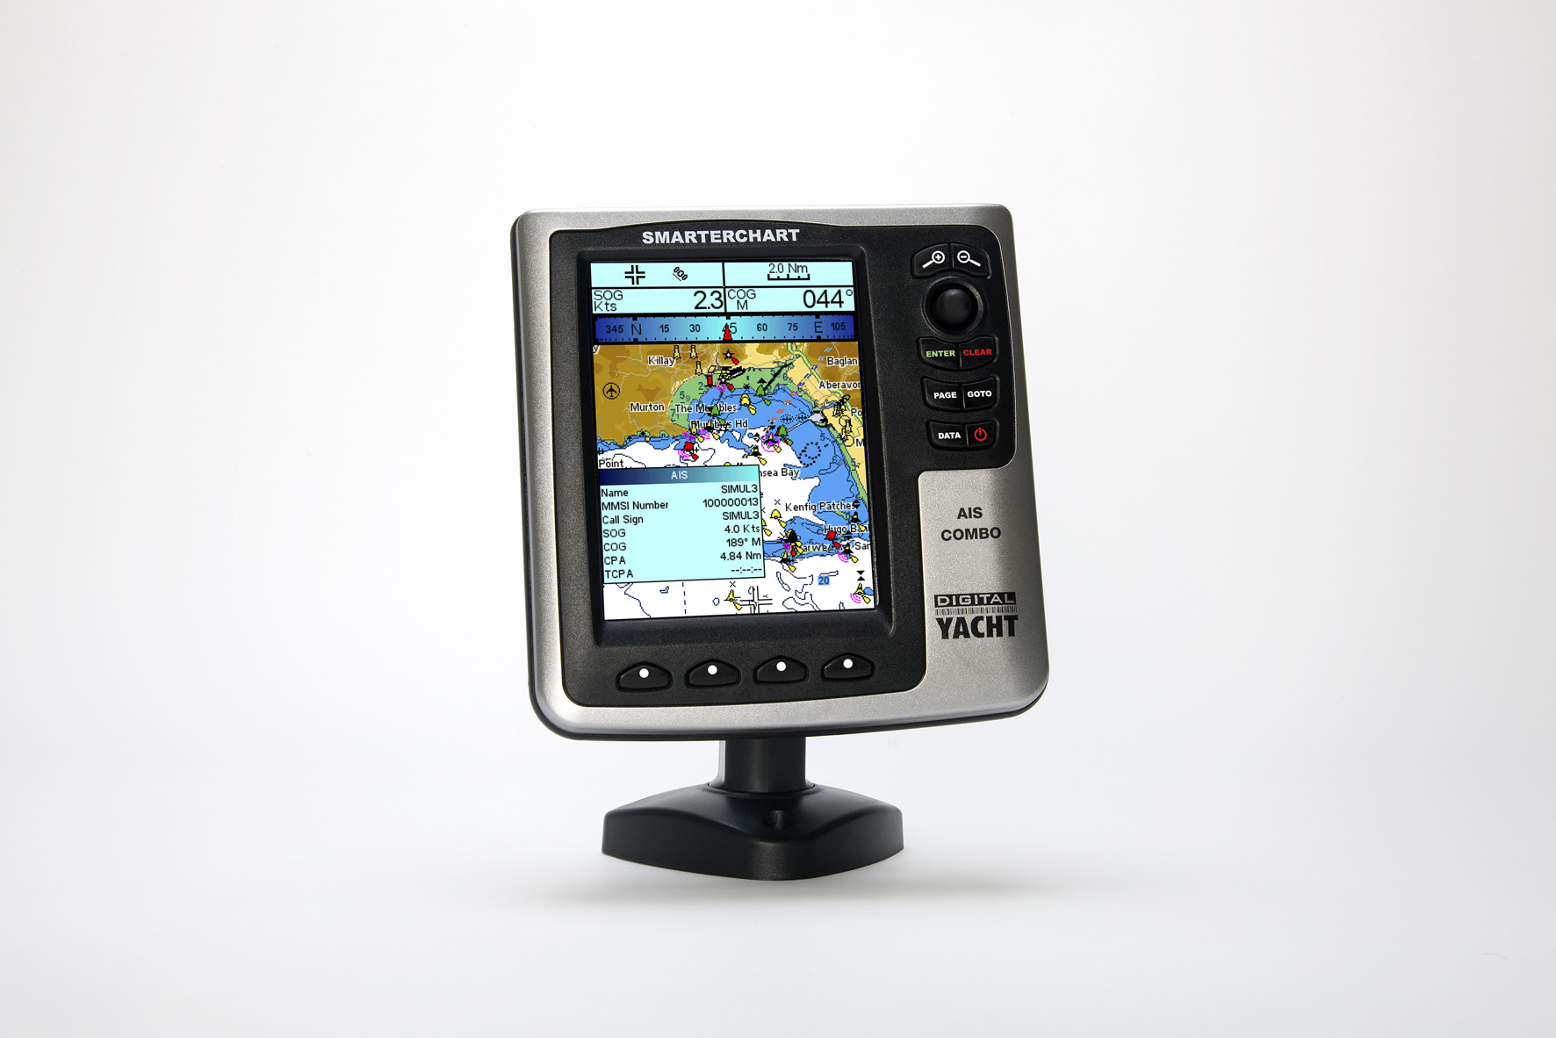
Previous generations of chart plotters generally required a separate AIS black box receiver to yield this functionality, but the SmarterChart range incorporate the technology inside which makes installation significantly easier with no complicated interfacing required. This effectively allows the unit to become a multi-function navigation device, overlaying the details of all ships and yachts equipped with AIS transponders, directly onto the chart plotter display.
All of the SmarterChart range are compatible with the latest C-Map MAX charting and all incorporate the very latest high sensitivity built in 50 channel GPS with optional external antenna versions also available. AIS functionality just requires the addition of a VHF antenna and there’s a simple plug-in BNC connection on the rear of the unit to facilitate this. Digital Yacht also offer a range of AIS-VHF antenna splitters so that the main VHF antenna can be used for both VHF DSC and AIS.
SmarterChart boasts all of the latest C Map Max features such as weather overlays through the C-Forecast system, satellite data imagery, animated buoys and lights, perspective 3-D view and waypoint or route transfer to a PC using the popular C Map PC Planner software. The unit has been made surprisingly easy to use thanks to the use of soft keys and all systems feature a clear 320 x 240 pixel sunlight viewable colour display.
There is no compromise on the AIS receiver technology that's utilised, with the SmarterChart 500 incorporating a true dual channel receiver - simultaneously picking up both AIS frequencies to ensure the best possible target tracking.
An AIS Class A transponder is now mandatory on all ships over 300GRT and essentially it sends the ship's position, course, speed and identity to other vessels within the vicinity. Transmission is over standard VHF frequencies so range is typically up to around 50 miles. The system greatly reduces the risk of collision as well as allowing yachtsmen to identify ships, establish voice contact and see their position overlaid on to a chart plotter, together with a closest point of approach calculation.
The basic SmarterChart 500 range will be available in December 2009. Prices start from £349 plus VAT.
Further details are available at www.digitalyacht.co.uk
- ENDS -
Notes for editors:
Digital Yacht
Established in 2001, Digital Yacht is a specialist manufacturer of marine navigation and communication equipment. Our product range includes marine PCs and monitors, TOUCH Navigation System, AIS receivers and transponders, high power WiFi, instrumentation, autopilots and equipment mounting solutions.
Digital Yacht products are available through a network of marine electronic specialist dealers, distributors and installers throughout the world.

For further information, please contact:
Digital Yacht Ltd., Digital House, Unit 10 City Business Park, Easton Road, Bristol, BS5 OSP, UK.
Telephone: +44 (0)1179 554474
Email: sales@digitalyacht.co.uk
www.digitalyacht.co.uk

For further press information, please contact:
Tina Mansell at The Mansell Agency
Telephone: +44 (0)1202 701705. Mobile: +44 (0)7973 850012
Email: tina@themansellagency.com
www.themansellagency.com

